Buy My Stuff

Final Report

Senior Project 1: Capstone

Team 4

Soualiho Diomande, John Rierson,

Ketrell Rogers, Rita Taylor

Version 1.0

December 1, 2021

**Table of Contents**

Contents

1. Executive Summary 3

1.1 Project Overview 3

1.2 Purpose and Scope of this Specification 3

2. Team Prospectus 3

3. Product/Service Description 3

3.1 Product Context 3

3.2 User Characteristics 4

3.3 Assumptions 4

3.4 Constraints 4

3.5 Dependencies 4

4. Requirements 4

4.1 Functional Requirements 4

4.2 User Interface Requirements 5

4.3 Usability 6

4.4 Performance 6

4.4.1 Capacity 7

4.4.2 Availability 7

4.4.3 Latency 7

4.5 Manageability/Maintainability 7

4.5.1 Monitoring 7

4.5.2 Maintenance 7

4.5.3 Operations 7

4.6 System Interface/Integration 7

4.6.1 Network and Hardware Interfaces 8

4.6.2 Systems Interfaces 8

4.7 Security 8

4.7.1 Protection 8

4.7.2 Authorization and Authentication 8

4.8 Data Management 9

4.9 Standards Compliance 9

4.10 Portability 9

5. User Scenarios/Use Cases 9

6. Specifications/Implementation Plan 10

7. Project Design Steps 10

8. Sample Site Code – Home Page 11

9. APPENDIX 17

Appendix A Definitions, Acronyms, and Abbreviations 17

Appendix B Weekly Journals 18

# Executive Summary

## Project Overview

This project is an E-Commerce website for North Carolina A&T students and staff members. The site offers COVID pandemic related items including masks, gloves, snacks, drinks and household cleaners. Once items are purchased, items can be delivered on campus or shipped. Customers can also register by creating a profile.

## Purpose and Scope of this Specification

**In scope**

This document addresses requirements related to the initial release of Buy My Stuff:

* Defining user interface requirements.
* Defining user characteristics
* Defining security protocols.

**Out of Scope**

The following items are out of scope:

* Defining code standards.
* Database relational schemas
* Network and hardware requirements.

# Team Prospectus

* **Rita Taylor-** Being our Team Lead and Team Captain she is the first point of contact when communicating with our Professor and setting up meetings with her. She also has extensive project management experience which makes her perfect for this role. She will be responsible for handling any issues or questions we might have as a group and expressing them to the Professor. She will also be instrumental in the website design with her background.
* **Soualiho Diomande** - Secretary and E-Commerce expert of our group. He will be recording and notating what is going on in the meetings but he will be the go to guy for this group. He has the most experience developing and building the website and e-commerce sites so he is our guru.
* **Ketrell Rogers-**  Strategic and creative thinker with all the skills. Ketrell will be the guy that if we need something done he will do it without asking. He will be intricate in the creative, branding, and programming process with his background in Linux and Python.
* **John Rierson-**Marketing gone techy. John will be another vital part of the creative and research process of this project. With an understanding of website design and business development he contributes on weekly calls.

# Product/Service Description

The following general factors affect the site and its requirements.

## Product Context

This website is like mini pandemic market for college students. It is somewhat independent, and self-contained. The relationships or components of the larger system, interconnections, and external interfaces:

1. Product quantity pages
2. Shipping costs

## User Characteristics

Products will be very limited and very limited in different skews their customer profile creations is going to be difficult to create. If anyone has ever ordered anything on the internet our e-commerce site is going be just as simple.

It will be very easy to use especially if you’re a student but lets say a parent decided to jump on the user’s credentials we can see their being a bit of a problem but not much of one because of the limited pages and products.

The general profile would be a Professor or Student with a current NC A&T email address. They would have a basic understanding of ordering products online previously and currently using other e-commerce sites. The tech savvy experience would range from 1 to 5, whereas 1 being someone that only orders a couple times a month online and 5 someone orders products daily.

## Assumptions

Product availability is going to be the most important aspect to our pandemic college e-commerce site and making sure that is lightning quick and updated live. If the product is not available or out of stock it should generate a message or email saying when it should be in stock. Site should work on major browser such as Chrome, Firefox, Safari, and mobile devices as well

## Constraints

Copyright and usage of the universities logo’s and colors for the design and layout could be a huge constraint. We want this to be specifically made for the students. Bigger picture we would need access to all the student records and One card information for it to fully functional and a fluid working website. This is if we were to sell it to the university.

Non-Working aggie e-mails and students that have graduated within the area. With every first protype their will be a couple loop holes

## Dependencies

* This product will require the ability to obtain addresses for buildings on campus for delivery requirements
* This product will require a web hosting service since the team does not own servers needed to host it.

# Requirements

## Functional Requirements

The following table list functional requirements.

|  |  |
| --- | --- |
| Section/ Requirement ID | Requirement Definition |
| FR 1.0 | The website shall accept customer orders |
| FR 1.1 | The website shall display an image and description of each product |
| FR 1.2 | The website shall restrict adding sold out items to the shopping cart |
| FR 1.3 | The website shall display a warning for products almost out of stock |
| FR 2.0 | The website shall allow users/customers to create a profile |
| FR 2.1 | The website shall require Aggie email addresses to create a profile |
| FR 2.2 | The website shall validate user profiles via email |
| FR 3.0 | The website shall display previous orders for customers with a profile created |
| FR 3.6 | The website shall allow users to login |
| FR 3.1 | The website shall be able to complete a sale |
| FR 3.2 | The website shall restrict range for delivery to 2 mile radius of A&T Main Campus |
| FR 3.3 | The website will allow shipping for users outside of the delivery range |
| FR 3.4 | The website shall NOT store credit card or banking information |
| FR 3.5 | The website shall produce a receipt detailing a customers’ purchase information |
| FR 3.7 | The website shall retain items in the shopping card when users log in |
| FR 3.8 | This website shall provide a shipping/order status |
| FR 4.0 | The website shall store customer and product data in a SQL database |

## User Interface Requirements

|  |  |  |  |
| --- | --- | --- | --- |
| Section/  Requirement ID | Requirement Type | Requirement Name | Notes |
| UI 1 | UI | Landing page |  |
| UI 2 | UI | Login page |  |
| UI 3 | UI | Checkout page |  |
| UI 4 | UI | Contact Us |  |
| UI 5 | UI | About Us |  |
| UI 6 | UI | Testimonies |  |
| UI 7 | UI | Product Pages |  |
| UI 8 | UI | Feedback | Product reviews on each page |
| UI 9 | Design | Top 5 products for foods | Display top 5 selling food items |
| UI 10 | Functionality | Restrict Delivery Zone | Do not allow selection of delivery outside of delivery zone |
| UI 11 | Design | Breadcrumbs | Display at top of each page |
| UI 12 | Design | Mobile Device Friendly |  |
| UI 13 | Functionality | Product Count |  |
| UI 14 | Functionality | Delivery Message |  |
| UI 15 | Design | Out of Stock messaging |  |
| UI 16 | Design | Consistent color scheme | Aggie colors (blue/gold/white) |
| UI 17 | Functionality | SSL selling encryption |  |
| UI 18 | Design | Display title ads |  |
| UI 19 | Functionality | Emailing list |  |
| UI 20 | UI | Terms of Agreement |  |
| UI 21 | UI | Refund Policy |  |

## Usability

**Must have Aggie email, would work with desktop and mobile devices**

Learnability

* The user documentation and help should be complete
* The help should be context sensitive and explain how to achieve common tasks
* The system should be easy to learn

## Performance

The performance of the website will be based on several factors. The factors can be due to the user internet Speed, Traffic on the website, and the traffic that takes place on the platform. In most cases, 99% of the transactions will be processed within a second if the user has strong internet data speed. If there are no activities from the users for a good 15 minutes the webpage will time-out.

### Capacity

The website can have more than 10000 users at the time before starting to glitch.

### Availability

The specific and measurable requirements for our E-commerce website is:

* The hours of operation are 24h/7 days
* The website will be available at any time and from anywhere but only students of NCAT will be able to make a purchase.
* There should be no Impact of downtime on users and business operations
* The Impact of scheduled and unscheduled maintenance on uptime and maintenance communications procedures will be less than 15%
* The website will be reliable at 100%

### Latency

The maximum acceptable time to complete a purchase after clicking on the checkout tab is 15 min.

## Manageability/Maintainability

### Monitoring

The administrators will be responsible for monitoring any activity regarding the website. Also, users have options to submit a claim whenever they encounter an issue with the website. All those claims are directed to the administrator as well. Once the issue is identified, the administrator will take proper action to fix the issue based on the severity.

### Maintenance

Maintenance will be done every Sunday from midnight to 6 AM. This time frame also will be used to update the website for example if we need to add some new products or remove some old products.

### Operations

The user will be able to surf around the website looking for product information, make purchase, create an account on our website, users can add the product they want to purchase in the basket and then come back later to make the purchase, the website will be secured so users will be able to add their credit card information onto their account.

## System Interface/Integration

The site should interface and integrate with the following products:

Operating systems:

* Windows
* mac OS
* Linux

Web Browsers

* Safari
* Google Chrome
* Firefox
* Microsoft edge/ Internet explorer
* tor browser

Severs

* Web Hosting

Database

* SQL

### Network and Hardware Interfaces

* Networking servers
* SQL servers
* Web Hosting servers

### Systems Interfaces

1. *System1-to-System2 Interface*

The <customer> will place an order and the system will create a ticket for the order. Once the order is placed, the customer will receive a message and the supply will also. The order will be fulfilled by 12:00 pm and shipped to the customer before 6 PM

***Order Description***

* 1. The OrderFile for each order
  2. Each row contains data for the order file/description
* Full name
* Address
* Order date
* Order number
* Amount paid
* Shipping status
* Email

## Security

### Protection

* Creating scheduled backups
* SSL
* encryption of domain and private information
* DDOS protection
* Secure admin username and passwords
* protection from SQL injection
* protection from xss attacks
* strong password policy
* using secured web hosting

### Authorization and Authentication

The site will use the following factors to authenticate users:

* Two way authentication
* Email authentication
* bot authentication
* Credit/debit card authentication

## Data Management

Initially, we will need all the same information like you were signing up for a new account to any other e-commerce site. The most vital pieces of information would be:

* valid and working NCA&T aggie e-mail address
* address either on campus or within that zip code proximity

The 2 pieces of information above are crucial for our site because we will need this to validate you as a student to initially sign up but also receive your products as you order them.

## Standards Compliance

Cookie Management- We need to have third party cookie policy agreements like every website does. Basically for marketing purposes.

Privacy Policy

TOS (“Terms of Service”)- This is the outline of how our product and services and how they work. Discusses the e-commerce site and its services and basically a legal document to make sure we explain everything in detail to our customers.

* Account creation- why we need it, what we are going to do with their information
* cancelation of order, return policy
* Explanation of costs
* facilitate or otherwise process payments and/ or another sensitive user data;

North Carolina has no statue against passing down the credit card fees on to the customers, something important to remember.

## Portability

If portability is a requirement, specify attributes of the system that relate to the ease of porting the system to other host machines and/or operating systems. For example,

* Percentage of components with host-dependent code;
* Percentage of code that is host dependent;
* Use of a proven portable language;
* Use of a particular compiler or language subset;
* Use of a particular operating system;
* The need for environment-independence - the product must operate the same regardless of operating systems, networks, development or production environments.

# User Scenarios/Use Cases

The following use case scenarios have been defined to help the team work through complex requirements:

# Specifications/Implementation Plan

Our site will be built with a database backend to store product and customer related data. During development, we will host it on our local machines then review options for hosting once development is near finished.

# Project Design Steps

To design the site, the team implemented the following steps:

* Brainstormed overall theme for the site’s content
* Developed an outline of the content to include on the site
* Determine the list of products to offer.
* Research e-commerce sites offering similar products
* Draft and review design concepts to determine the layout of the site
* Brainstorm and draft user interface requirements and site themes
* Document system requirements
* Finalize list of use cases and draft diagrams to determine flow of each
* Build CSS files for standard styles
* Draft and review templates of each type of page (product list page, product detail page and customer registration page)

# Sample Site Code – Home Page

<!DOCTYPE html>

<html>

<head>

<!-- Basic -->

<meta charset="utf-8" />

<meta http-equiv="X-UA-Compatible" content="IE=edge" />

<!-- Mobile Metas -->

<meta name="viewport" content="width=device-width, initial-scale=1, shrink-to-fit=no" />

<!-- Site Metas -->

<link rel="icon" href="images/fevicon.png" type="image/gif" />

<meta name="keywords" content="" />

<meta name="description" content="" />

<meta name="author" content="" />

<title>Final Project Prototype</title>

<!-- bootstrap core css -->

<link rel="stylesheet" type="text/css" href="css/bootstrap.css" />

<!-- fonts style -->

<link href="<https://fonts.googleapis.com/css2?family=Roboto:wght@400;500;700;900&display=swap>" rel="stylesheet">

<!-- font awesome style -->

<link href="css/font-awesome.min.css" rel="stylesheet" />

<!-- Custom styles for this template -->

<link href="css/style.css" rel="stylesheet" />

<!-- responsive style -->

<link href="css/responsive.css" rel="stylesheet" />

</head>

<body>

<!-- header section strats -->

<header class="header_section">

<div class="container">

<nav class="navbar navbar-expand-lg custom_nav-container ">

<a class="navbar-brand" href="index.html">

<span>Buy My Stuff</span>

</a>

<button class="navbar-toggler" type="button" data-toggle="collapse" data-target="#navbarSupportedContent" aria-controls="navbarSupportedContent" aria-expanded="false" aria-label="Toggle navigation">

<span class=""> </span>

</button>

<div class="collapse navbar-collapse" id="navbarSupportedContent">

<ul class="navbar-nav ml-auto">

<li class="nav-item active">

<a class="nav-link" href="index.html">Home <span class="sr-only">(current)</span></a>

</li>

<li class="nav-item">

<a class="nav-link" href="about.html"> About</a>

</li>

<li class="nav-item">

<a class="nav-link" href="fruit.html">Snack/Produts</a>

</li>

<li class="nav-item">

<a class="nav-link" href="fruit.html">Register</a>

</li>

<li class="nav-item">

<a class="nav-link" href="blog.html">Our Story</a>

</li>

<li class="nav-item">

<a class="nav-link" href="contact.html">Contact Us</a>

</li>

<li class="nav-item">

<a class="nav-link" href="contact.html">Check Out</a>

</li>

</ul>

</div>

</nav>

</div>

</header>

<!-- end header section -->

<!-- slider section -->

<section class="slider_section ">

<div id="customCarousel1" class="carousel slide" data-ride="carousel">

<div class="carousel-inner">

<div class="carousel-item active">

<div class="container ">

<div class="row">

<div class="col-md-6 col-lg-5">

<div class="detail-box">

<h1>

We Sell <br>

Snack AND PPE Equipment on Campus

</h1>

<p>

We understand that with the distance away from familly, life can be hard time to time. We offer you a variety of Organic snack for student living on campus. </p>

<div class="btn-box">

<a href="" class="btn-1">

Read More

</a>

<a href="" class="btn-2">

Contact Us

</a>

</div>

</div>

</div>

<div class="col-md-6 col-lg-7">

<div class="img-box">

<img src="images/slider-img.png" alt="">

</div>

</div>

</div>

</div>

</div>

<div class="carousel-item">

<div class="container ">

<div class="row">

<div class="col-md-6 col-lg-5">

<div class="detail-box">

<h1>

We Sell <br>

Snack AND PPE Equipment on Campus

</h1>

<p>

Anything embarrassing hidden in the middle of text. All the Lorem Ipsuanything embarrassing hidden in the middle of text. All the Lorem Ipsumm </p>

<div class="btn-box">

<a href="" class="btn-1">

Read More

</a>

<a href="" class="btn-2">

Contact Us

</a>

</div>

</div>

</div>

<div class="col-md-6 col-lg-7">

<div class="img-box">

<img src="images/slider-img.png" alt="">

</div>

</div>

</div>

</div>

</div>

<div class="carousel-item">

<div class="container ">

<div class="row">

<div class="col-md-6 col-lg-5">

<div class="detail-box">

<h1>

We Sell <br>

Snack AND PPE Equipment on Campus

</h1>

<p>

Anything embarrassing hidden in the middle of text. All the Lorem Ipsuanything embarrassing hidden in the middle of text. All the Lorem Ipsumm </p>

<div class="btn-box">

<a href="" class="btn-1">

Read More

</a>

<a href="" class="btn-2">

Contact Us

</a>

</div>

</div>

</div>

<div class="col-md-6 col-lg-7">

<div class="img-box">

<img src="images/slider-img.png" alt="">

</div>

</div>

</div>

</div>

</div>

</div>

<ol class="carousel-indicators">

<li data-target="#customCarousel1" data-slide-to="0" class="active"></li>

<li data-target="#customCarousel1" data-slide-to="1"></li>

<li data-target="#customCarousel1" data-slide-to="2"></li>

</ol>

</div>

</section>

<!-- end slider section -->

<!-- offer section -->

<section class="offer_section">

<div class="container-fluid">

<div class="row">

<div class="col-md-7 px-0">

<div class="box offer-box1">

<img src="images/S2.jpg" alt="">

<div class="detail-box">

<h2>

Upto 10% Off

</h2>

<a href="">

Shop Now

</a>

</div>

</div>

</div>

<div class="col-md-5 px-0">

<div class="box offer-box2">

<img src="images/S4.jpg" alt="">

<div class="detail-box">

<h2>

Upto 50% Off

</h2>

<a href="">

Shop Now

</a>

</div>

</div>

<div class="box offer-box3">

<img src="images/S3.jpg" alt="">

<div class="detail-box">

<h2>

Upto 15% Off

</h2>

<a href="">

Shop Now

</a>

</div>

</div>

</div>

</div>

</div>

</section>

<!-- end offer section -->

<!-- product section -->

<section class="product_section layout_padding">

<div class="container">

<div class="heading_container heading_center">

<h2>

Our Snacks

</h2>

<p>

which don't look even slightly believable. If you are going to use a passage of Lorem Ipsum, you need to be sure there isn't an

</p>

</div>

<div class="row">

<div class="col-sm-6 col-lg-4">

<div class="box">

<div class="img-box">

<img src="images/p1.png" alt="">

</div>

<div class="detail-box">

<span class="rating">

<i class="fa fa-star" aria-hidden="true"></i>

<i class="fa fa-star" aria-hidden="true"></i>

<i class="fa fa-star" aria-hidden="true"></i>

<i class="fa fa-star" aria-hidden="true"></i>

<i class="fa fa-star-half-o" aria-hidden="true"></i>

</span>

<a href="">

Orange

</a>

<div class="price_box">

<h6 class="price_heading">

<span>$</span> 10.00

</h6>

</div>

</div>

</div>

</div>

<div class="col-sm-6 col-lg-4">

<div class="box">

<div class="img-box">

<img src="images/p2.png" alt="">

</div>

<div class="detail-box">

<span class="rating">

<i class="fa fa-star" aria-hidden="true"></i>

<i class="fa fa-star" aria-hidden="true"></i>

<i class="fa fa-star" aria-hidden="true"></i>

<i class="fa fa-star" aria-hidden="true"></i>

<i class="fa fa-star-half-o" aria-hidden="true"></i>

</span>

<a href="">

Durian

</a>

<div class="price_box">

<h6 class="price_heading">

<span>$</span> 10.00

</h6>

</div>

</div>

</div>

</div>

<div class="col-sm-6 col-lg-4">

<div class="box">

<div class="img-box">

<img src="images/p3.png" alt="">

</div>

<div class="detail-box">

<span class="rating">

<i class="fa fa-star" aria-hidden="true"></i>

<i class="fa fa-star" aria-hidden="true"></i>

<i class="fa fa-star" aria-hidden="true"></i>

<i class="fa fa-star" aria-hidden="true"></i>

<i class="fa fa-star-half-o" aria-hidden="true"></i>

</span>

<a href="">

Kiwi

</a>

<div class="price_box">

<h6 class="price_heading">

<span>$</span> 10.00

</h6>

</div>

</div>

</div>

</div>

<div class="col-sm-6 col-lg-4">

<div class="box">

<div class="img-box">

<img src="images/p4.png" alt="">

</div>

<div class="detail-box">

<span class="rating">

<i class="fa fa-star" aria-hidden="true"></i>

<i class="fa fa-star" aria-hidden="true"></i>

<i class="fa fa-star" aria-hidden="true"></i>

<i class="fa fa-star" aria-hidden="true"></i>

<i class="fa fa-star-half-o" aria-hidden="true"></i>

</span>

<a href="">

Mango

</a>

<div class="price_box">

<h6 class="price_heading">

<span>$</span> 10.00

</h6>

</div>

</div>

</div>

</div>

<div class="col-sm-6 col-lg-4">

<div class="box">

<div class="img-box">

<img src="images/p5.png" alt="">

</div>

<div class="detail-box">

<span class="rating">

<i class="fa fa-star" aria-hidden="true"></i>

<i class="fa fa-star" aria-hidden="true"></i>

<i class="fa fa-star" aria-hidden="true"></i>

<i class="fa fa-star" aria-hidden="true"></i>

<i class="fa fa-star-half-o" aria-hidden="true"></i>

</span>

<a href="">

Banana

</a>

<div class="price_box">

<h6 class="price_heading">

<span>$</span> 10.00

</h6>

</div>

</div>

</div>

</div>

<div class="col-sm-6 col-lg-4">

<div class="box">

<div class="img-box">

<img src="images/p6.png" alt="">

</div>

<div class="detail-box">

<span class="rating">

<i class="fa fa-star" aria-hidden="true"></i>

<i class="fa fa-star" aria-hidden="true"></i>

<i class="fa fa-star" aria-hidden="true"></i>

<i class="fa fa-star" aria-hidden="true"></i>

<i class="fa fa-star-half-o" aria-hidden="true"></i>

</span>

<a href="">

Apple

</a>

<div class="price_box">

<h6 class="price_heading">

<span>$</span> 10.00

</h6>

</div>

</div>

</div>

</div>

</div>

<div class="btn-box">

<a href="">

View All

</a>

</div>

</div>

</section>

<!-- end product section -->

# APPENDIX

# Appendix A Definitions, Acronyms, and Abbreviations

Please note the following abbreviation definitions:

* UI – User Interface
* DDOS – Distributed Denial of Service
* XSS – Cross Site Scripting

# Appendix B Weekly Journals

**Week 1: Project Journal**

**Fall 2021**

**Submitted By:**

**Soualigh Diomande, John Rierson, Ketrell Rogers, Rita Taylor**

**Week Ending: August 27th 2021**

* **Accomplishment 1: Group Introductions**

Since all of our members are remote, we established a group chat for immediate and information communications. We each joined the group and introduced ourselves.

* **Accomplishment 2: Determine Project Topic**
* Our group had multiple Zoom meetings to brainstorm and decide on the topic we wanted our project to cover. Considering the times and current events, we decided to do a project centered around COVID-19 necessities. Our project will be to build an e-commerce website that would sell COVID-19 related products.
* **Accomplishment 3: Gain Approval for Our Project**

We determined a date/time when everyone would be available, then scheduled a Zoom meeting with Dr. Sowells-Boone to discuss our project topic. During this meeting, we presented the topic and described it, at a high level. We also covered expectations for the level of difficulty our project should entail and semester checkpoints.

* **Individual Group Member Contribution: Soualiho Diomande**

The team determined that Suoaliho will be our Secretary. Soualiho participated in group discussions to help determine the project topic, gain approval from Dr. Sowells-Boone and documented a summary of the project topic

* **Individual Group Member Contribution: John Rierson**

John participated in group discussions to help determine the project topic and to gain approval from Dr. Sowells-Boone

* **Individual Group Member Contribution: Ketrell Rogers**

Ketrell participated in group discussions to help determine the project topic and to gain approval from Dr. Sowells-Boone

* **Individual Group Member Contribution: Rita Taylor**

The team determined that Rita will be our Team Captain. Rita created the team’s group chat messaging platform, scheduled meetings and participated in group discussions to help determine the project topic and to gain approval from Dr. Sowells-Boone and

* **Issues and Solutions**

One member did not respond to attempts to connect. The team met with Dr. Sowells-Boone and agreed to have him removed from the group.

* **Acquired References and Dialogue**

NA

* **Goals for Next Week**
  + **Goal 1: Develop Initial Outline of Site**

We will meet to brainstorm ideas for organizing the site. Our goal is to have a first draft of the pages of the site, which will be refined as we go through development.

* + **Goal 2: Determine Initial Project Schedule**

Determine a timeline for designing, developing and testing the site.

* **Goal 3: Document List of Products to Showcase**

During team meetings, we will brainstorm ideas for products to showcase on the site and document them. Once documented we will categorize them, then begin searching for product images.

**Attach weekly work here**

* **Drafts Products to Showcase:**
  + **PPE**
  + **Masks**
  + **Gloves**
  + **Snacks**
  + **Candy bars**
  + **Popcorn**
  + **Fruit**
* **Cleaning Supplies**
  + **Initial Project Schedule:**
  + **Site Design -**

**Week 2: Project Journal**

**Fall 2021**

**Submitted By:**

**Soualiho Diomande, John Rierson, Ketrell Rogers, Rita Taylor**

**Week Ending: September 3rd 2021**

* **Accomplishment 1: Develop Initial Outline of Site**

We were able to assign each task of the project to each individual. We will meet-up every two days to provide updates on the evolution of the project.

* **Accomplishment 2: Determine Initial Project Schedule**

We were able to determine the initial project schedule based on each individual task. The Goal is to have it done by the end of the semester.

* **Accomplishment 3: Document List of Products to Showcase**

We determined that the list of products to showcase will be: Welcome page, Home page, Category page, product page, Create Account/Login, Shopping cart, Checkout page, Order page, Contact us, and Feedback.

* **Individual Group Member Contribution: Soualiho Diomande**

Soualiho participated in group discussions, created an online Docx for the weekly journal so each member of the group can go ahead and update the document. He also completed the Accomplishments for this week.

* **Individual Group Member Contribution: John Rierson**

John participated in group discussions and he completed the project topic.

* **Individual Group Member Contribution: Ketrell Rogers**

Ketrell participated in group discussions and he defined the initial outline of the site.

* **Individual Group Member Contribution: Rita Taylor**

Rita created the team’s group chat messaging platform, and assisted each other members complete their part. On top of that also, she also created the Goal for Next Week.

* **Issues and Solutions**

One member did not respond to attempts to connect. The team met with Dr. Sowells-Boone and agreed to have him removed from the group.

* **Acquired References and Dialogue**

NA

* **Goals for Next Week**
  + **Goal 1: Draft Concepts**
  + **Goal 2: Mid Term Presentation**

**Attach weekly work here**

**Develop Initial Outline of Site**

We will meet to brainstorm ideas for organizing the site. Our goal is to have a first draft of the pages of the site, which will be refined as we go through development.

· Welcome Page

o Information About the website and what is being sold

o How we created the Idea of the website

o Paragraphs and pictures of what is being sold

o Social Media at the bottom of every page

· Home Page

o Most Bought and featured products

o Any products on sale

· Category Page

o Shows categories

o Separate categories by filters

· Product Page

o Shows all products

o Filter products

· Create Account/Login Page

o Users can create an account

o Use account to shop

· Shopping Cart

o Shows items in cart

o Proceed to checkout Page

· Checkout Page

o Checkout page

o Checkout for guest with no created account

· Order Page

o Check Orders

o When item has been shipped

o Cancel orders

o Add onto orders

· Contact Us page

o Information to contact

o Email for support

· Feedback Page

o Customers can give their testimonies

**Determine Initial Project Schedule**

Determine a timeline for designing, developing and testing the site.

|  |  |  |  |  |  |
| --- | --- | --- | --- | --- | --- |
| **Task Name** | **Duration** | **Start** | **Finish** | **Predecessors** | **Resource Names** |
| **Sr. Project - COVID eCommerce Site** | 72 days? | Mon 8/23/21 | Tue 11/30/21 |  |  |
| **Planning Design Process** | 3 days? | Mon 8/23/21 | Wed 8/25/21 |  |  |
| Team Introductions | 1 day? | Mon 8/23/21 | Mon 8/23/21 |  | Soualiho,James,Ketrell,Rita |
| Select Team Roles | 1 day? | Tue 8/24/21 | Tue 8/24/21 | 3 | Soualiho,James,Ketrell,Rita |
| Establish Meeting Cadence | 1 day? | Wed 8/25/21 | Wed 8/25/21 | 4 | Soualiho,James,Ketrell,Rita |
| **Preliminary Design** | 34 days | Thu 8/26/21 | Tue 10/12/21 |  |  |
| Draft Outline of Site Design | 1 wk | Thu 8/26/21 | Wed 9/1/21 | 5 | Ketrell |
| Draft List of Products to Offer | 1 wk | Thu 8/26/21 | Wed 9/1/21 | 7SS | James |
| Draft Concepts | 3 wks | Thu 9/2/21 | Wed 9/22/21 | 8 | Rita,Soualiho,James,Ketrell |
| Mid Term Presentation | 14 days | Thu 9/23/21 | Tue 10/12/21 | 9 | Soualiho,James,Ketrell,Rita |
| **Embodiment Design** | 35 days | Wed 10/13/21 | Tue 11/30/21 |  |  |
| Determine Color Schemes | 2 wks | Wed 10/13/21 | Tue 10/26/21 | 10 | Soualiho,James,Ketrell,Rita |
| Design Prototype | 3 wks | Wed 10/27/21 | Tue 11/16/21 | 12 | Soualiho,James,Ketrell,Rita |
| Design Database Schema | 2 wks | Wed 11/17/21 | Tue 11/30/21 | 13 | Soualiho,James,Ketrell,Rita |

**Document List of Products to Showcase**

During team meetings, we will brainstorm ideas for products to showcase on the site and document them. Once documented we will categorize them, then begin searching for product images.

We discussed as a group the products we put on this E-Commerce is going to pertain to NC A&T Students but more importantly deal with items that students would need during the current Pandemic. We broke down the items into two categories. The first category being PPE Products. The second category would items that students could purchase at the campus food store (non-refrigerated).

**PPE Category:**

* Masks (medical and NC A&T gear for production, face shields)
* Hand sanitizer
* Multi surface bacterial cleaner
* Lysol Wipes

**Student food items & misc**

* Cereal
* Lunch items (ramen noodle, any meal items that doesn’t to be refrigerated)
* Snack items (chips, candy, multigrain bars, etc)
* Drinks (Soda, water, gatorade)
* Still working on more specific items

**Week 3: Project Journal**

**Fall 2021**

**Submitted By:**

**Soualiho Diomande, John Rierson, Ketrell Rogers, Rita Taylor**

**Week Ending: September 10th 2021**

* **Accomplishment 1: Draft Concepts**

Brainstorming ideas for layout each page, including welcome page. Research other eCommerce sites for ideas, including Shopify. Researching design concepts with flavors of blue, similar to NCAT. Also researching design effects of colors.

* **Accomplishment 2: Conducted Site Demo**

Soualiho has experience developing eCommerce sites and demo’d a site he recently created to help generate ideas from the team.

* **Accomplishment 3:**

NA

* **Individual Group Member Contribution: Soualiho Diomande**

Soualiho demo’d site he recently created.

* **Individual Group Member Contribution: John Rierson**

John participated in site demo. Contributed to site design concept research.

* **Individual Group Member Contribution: Ketrell Rogers**

Ketrell participated in site demo. Contributed to site design concept research.

* **Individual Group Member Contribution: Rita Taylor**

Rita participated in site demo. Contributed to site design concept research.

* **Issues and Solutions**

NA.

* **Acquired References and Dialogue**

NA

* **Goals for Next Week**
  + **Goal 1: Continue Drafting Concepts**
  + **Goal 2: Complete Project Planning Report**

**Attach weekly work here**

Examples of sites visited for ideas on themes, colors, etc



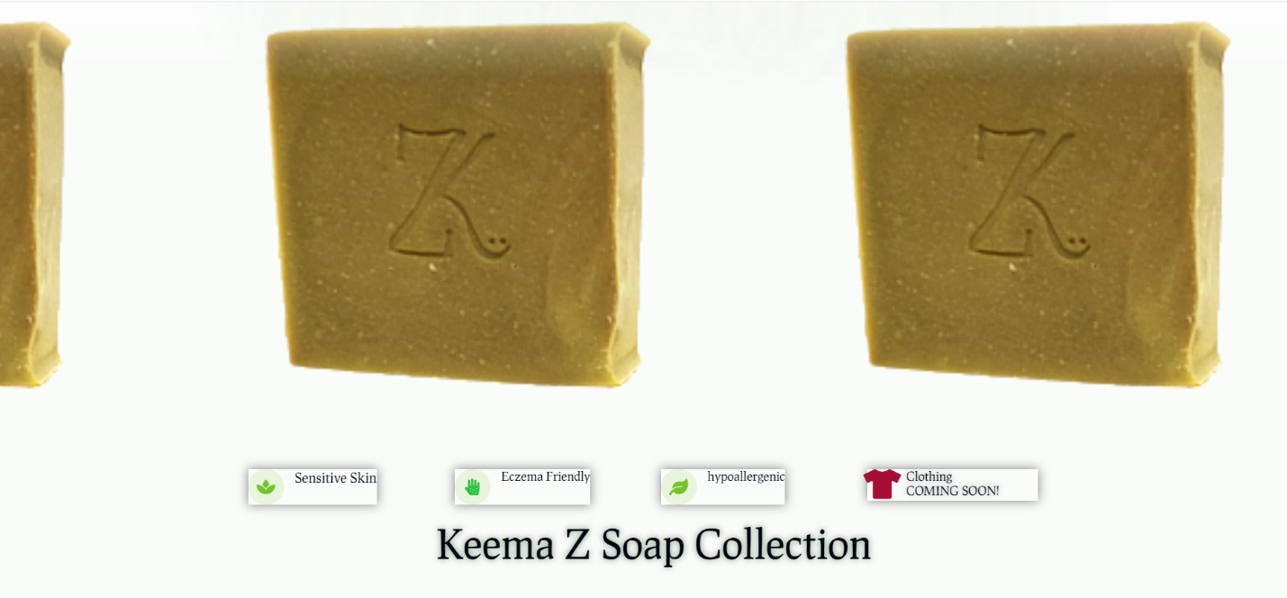

**Week 5: Project Journal**

**Fall 2021**

**Submitted By:**

**Soualiho Diomande, John Rierson, Ketrell Rogers, Rita Taylor**

**Week Ending: September 24th 2021**

* **Accomplishment 1: Brainstorm User Interface Requirements**

The team met to brainstorm and define user interface requirements

* **Accomplishment 2: Brainstorm Theme Ideas**

Reviewed several eCommerce sites for ideas then brainstormed a theme for ours, including color scheme, layout and site options.

* **Accomplishment 3: Next Steps - Roles & Responsibilities**

Assigned roles and responsibilities for completing midterm report and set meeting times to meet with status updates and edits

* **Individual Group Member Contribution: Soualiho Diomande**

Soualiho participated in brainstorming sessions.

* **Individual Group Member Contribution: John Rierson**

John participated in brainstorming sessions and documented requirements during sessions

* **Individual Group Member Contribution: Ketrell Rogers**

Ketrell participated in brainstorming sessions

* **Individual Group Member Contribution: Rita Taylor**

Rita participated in brainstorming sessions

* **Issues and Solutions**

NA.

* **Acquired References and Dialogue**

NA

* **Goals for Next Week**
  + **Goal 1: Continue Drafting Requirements. Identify priority levels for each**
  + **Goal 2: Begin Drafting Midterm Report**

**Attach weekly work here**

**DRAFT User Requirements:**

* Landing page ,
* login page ( using Aggie email and confirming account after email sent),
* shopping cart,
* check out page,
* feedback,
* contact us,
* about us,
* testimonies,
* product pages,
* top 5 products for foods,
* delivery zone = 27411 anything else shipping costs,
* breads crumbs,
* mobile friendly,
* product count,
* delayed delivery message,
* message on screen out of stock and no shopping cart.
* User interface- consistent color scheme ( Aggies Colors Blue/Gold/White/)
* SSL selling encryption/ security for payments and user information. Display.Tile ads , e-mailing lists,
* Terms of Agreement,
* Refund Policy

**Roles/Responsibilities - Midterm Report:**

* Security - Ketrell and System Interface/Integration
* Functional Requirements/User Scenarios/Use Cases - Rita
* Product/Service Description, Data Management, Standards Compliance - John
* Performance, Manageability/Maintainability - Soualiho

**Week 6: Project Journal**

**Fall 2021**

**Submitted By:**

**Soualiho Diomande, John Rierson, Ketrell Rogers, Rita Taylor**

**Week Ending: October 1, 2021**

* **Accomplishment 1: Draft Midterm Report - Requirements**

The team reviewed a draft of the functional requirements and mapped them to the User Interface requirements previously defined.

* **Accomplishment 2: Draft Midterm Report – Product/Service Description**

The team reviewed a draft of the Product/Service Description section and made recommendations.

* **Accomplishment 3: Next Steps - Roles & Responsibilities**

Assigned roles and responsibilities for completing midterm report and set meeting times to meet with status updates and edits

* **Individual Group Member Contribution: Soualiho Diomande**

Soualiho participated in the content review sessions and mapped User Interface Requirements to Functional Requirements along with the team.

* **Individual Group Member Contribution: John Rierson**

John drafted content for the Product/Service Description section of the midterm report

* ***Individual Group Member Contribution: Ketrell Rogers***

Ketrell participated in the content review sessions and mapped User Interface Requirements to Functional Requirements along with the team

* **Individual Group Member Contribution: Rita Taylor**

Rita drafted content for the Functional Requirements section and mapped User Interface Requirements to them along with the team.

* **Issues and Solutions**

NA.

* **Acquired References and Dialogue**

NA

* **Goals for Next Week**
  + **Goal 1: Finalize Draft of Midterm Report**

**Attach weekly work here**

DRAFT Functional Requirements:

|  |  |
| --- | --- |
| **Section/ Requirement ID** | **Requirement Definition** |
| FR 1.0 | The website shall accept customer orders |
| FR 1.1 | The website shall display an image and description of each product |
| FR 1.2 | The website shall restrict adding sold out items to the shopping cart |
| FR 1.3 | The website shall display warning for products almost out of stock |
| FR 2.0 | The website shall allow users/customers to create a profile |
| FR 2.1 | The website shall require Aggie email addresses to create a profile |
| FR 2.2 | The website shall validate user profiles via email |
| FR 3.0 | The website shall display previous orders for customers with a profile created |
| FR 3.6 | The website shall allow users to login |
| FR 3.1 | The website shall be able to complete a sale |
| FR 3.2 | The website shall restrict range for delivery to 2 mile radius of A&T Main Campus |
| FR 3.3 | The website will allow shipping for users outside of the delivery range |
| FR 3.4 | The website shall NOT store credit card or banking information |
| FR 3.5 | The website shall produce a receipt detailing a customers’ purchase information |
| FR 3.7 | The website shall retain items in the shopping card when users log in |
| FR 3.8 | This website shall provide a shipping/order status |
| FR 4.0 | The website shall store customer and product data in a SQL database |

**DRAFT: Product/Service Description :**

This website is like mini pandemic market for college students. It is somewhat independent and self contained. The relationships or components of the larger system, interconnections, and external interfaces:

Product quantity pages

Shipping costs

***User Characteristics***

So because our products will be very limited and very limited in different skews their customer profile creations is going to be difficult to create. If anyone has ever ordered anything on the internet our e-commerce site is going be just as simple.

It will be very easy to use especially if you’re a student but lets say a parent decided to jump on the user’s credentials we can see their being a bit of a problem but not much of one because of the limited pages and products.

*Assumptions*

Product availability is going to be the most important aspect to our pandemic college e-commerce site and making sure that is lightning quick and updated live. If the product is not available or out of stock it should generate a message or email saying when it should be in stock. Site should work on major browser such as Chrome, Firefox, Safari,and mobile devices as well

*Constraints*

Copyright and usage of the universities logo’s and colors for the design and layout could be a huge constraint. We want this to be specifically made for the students. Bigger picture we would need access to all the student records and One card information for it to fully functional and a fluid working website. This is if we were to sell it to the university.

Non Working aggie e-mails and students that have graduated within the area. With every first protype their will be a couple loop holes

**Week 7: Project Journal**

**Fall 2021**

**Submitted By:**

**Soualiho Diomande, John Rierson, Ketrell Rogers, Rita Taylor**

**Week Ending: October , 2021**

* **Accomplishment 1: Finalized Requirements**

The team discussed and reviewed all the requirements needed to complete the project. Figured out what requirements needed further research.

* **Accomplishment 2: Draft PowerPoint**

The team started a draft of the PowerPoint for the presentation and made recommendations.

* **Accomplishment 3: Next Steps - Roles & Responsibilities**

Assigned roles and responsibilities for completing midterm PowerPoint and set a couple times to run through the presentation.

* **Individual Group Member Contribution: Soualiho Diomande**

Soualiho reviewed Manageability and Maintainability in the Requirements Specifications. He went into depth about the Maintenance, Monitoring and Operations. He also discussed the Performance section as well.

* **Individual Group Member Contribution: John Rierson**

John reviewed the Product Context, User Characteristics, Assumptions, Dependencies, and Constraints. He discussed the Data Management and Standards Compliance

* **Individual Group Member Contribution: Ketrell Rogers**

Ketrell reviewed the System Interface and Integration portion. He discussed the Network/Hardware Interfaces and System Interfaces. He discussed the Security regarding the Protection, Authentication and Authorization portion.

* **Individual Group Member Contribution: Rita Taylor**

Rita reviewed the Project Overview and Purpose/ Scope of the Specification. She discussed the Functional Requirements along with User Interface Requirements and Usability. She also reviewed the cases and discussed any shipping issues from previous meetings.

* **Issues and Solutions**

NA.

* **Acquired References and Dialogue**

NA

* **Goals for Next Week**
  + **Goal 1: Finalize Draft of Midterm Report**
  + **Goal 2: Presentation of the Midterm Report.**

**Attach weekly work here**

DRAFT Functional Requirements:

|  |  |
| --- | --- |
| **Section/ Requirement ID** | **Requirement Definition** |
| FR 1.0 | The website shall accept customer orders |
| FR 1.1 | The website shall display an image and description of each product |
| FR 1.2 | The website shall restrict adding sold out items to the shopping cart |
| FR 1.3 | The website shall display warning for products almost out of stock |
| FR 2.0 | The website shall allow users/customers to create a profile |
| FR 2.1 | The website shall require Aggie email addresses to create a profile |
| FR 2.2 | The website shall validate user profiles via email |
| FR 3.0 | The website shall display previous orders for customers with a profile created |
| FR 3.6 | The website shall allow users to login |
| FR 3.1 | The website shall be able to complete a sale |
| FR 3.2 | The website shall restrict range for delivery to 2 mile radius of A&T Main Campus |
| FR 3.3 | The website will allow shipping for users outside of the delivery range |
| FR 3.4 | The website shall NOT store credit card or banking information |
| FR 3.5 | The website shall produce a receipt detailing a customers’ purchase information |
| FR 3.7 | The website shall retain items in the shopping card when users log in |
| FR 3.8 | This website shall provide a shipping/order status |
| FR 4.0 | The website shall store customer and product data in a SQL database |

**DRAFT: Availability/Security Description** :

The website should be available for users and secured since they will use their credit card information, it is defined as follow:

**Availability**

* The specific and measurable requirements for our E-commerce website is:
* The hours of operation are 24h/7 days
* The website will be available at any time and from anywhere but only students of NCAT will be able to make a purchase.
* There should be no Impact of downtime on users and business operations
* The Impact of scheduled and unscheduled maintenance on uptime and maintenance communications procedures will be less than 15%
* The website will be reliable at 100%

**Security**

* Specify the factors that will protect the system from malicious or accidental access, modification, disclosure, destruction, or misuse. For example:
* Creating scheduled backups
* SSL
* encryption of domain and private information
* DDOS protection
* Secure admin username and passwords
* protection from SQL injection
* protection from xss attacks
* strong password policy
* using secured web hosting

**Week 8: Project Journal**

**Fall 2021**

**Submitted By:**

**Soualiho Diomande, John Rierson, Ketrell Rogers, Rita Taylor**

**Week Ending: October 15th, 2021**

* **Accomplishment 1: Finalized Midterm Report**

The team finalized the midterm project report and submitted for grading

* **Accomplishment 2: Draft Mock Up of Site Home Page**

The team developed a mockup of the site’s home page using the color scheme previously discussed. This design may change once we begin coding.

* **Accomplishment 3: Finalize Midterm Presentation**

The team completed a PowerPoint presentation summarizing the midterm report, then created a video recording it. The final video and presentation slides were submitted for grading.

* **Accomplishment 4: Document Use Case Diagrams**

The team documented two UML diagrams detailing the decisions made in three use cases: shipping vs delivery and requirement of having an Aggie email to register for the site.

* **Individual Group Member Contribution: Soualiho Diomande**

Soualiho presented Manageability and Maintainability in the Requirements Specifications. He went into depth about the Maintenance, Monitoring and Operations. He also discussed the Performance section as well.

* **Individual Group Member Contribution: John Rierson**

John presented the Product Context, User Characteristics, Assumptions, Dependencies, and Constraints. He discussed the Data Management and Standards Compliance. We also discussed how we would pitch this idea further if we did not get authorization from the University to partner or to use their data or logo.

* **Individual Group Member Contribution: Ketrell Rogers**

Ketrell presented the System Interface and Integration portion. He discussed the Network/Hardware Interfaces and System Interfaces. He discussed the Security regarding the Protection, Authentication and Authorization portion.

* **Individual Group Member Contribution: Rita Taylor**

Rita presented the Project Overview and Purpose/ Scope of the Specification. She discussed the Functional Requirements along with User Interface Requirements and Usability. She also discussed the cases and discussed any shipping issues from previous meetings.

* **Issues and Solutions**

NA.

* **Acquired References and Dialogue**

NA

* **Goals for Next Week**
  + **Goal 1: Finalize PPE, Hygiene, Market Products**
  + **Goal 2: Discuss progress of coding and any issues**

**Attach weekly work here**

**Midterm Report Presentation Cover Page**

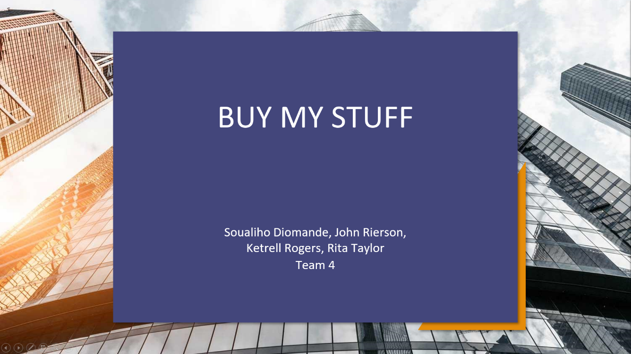

**Site Product Page Mockup**

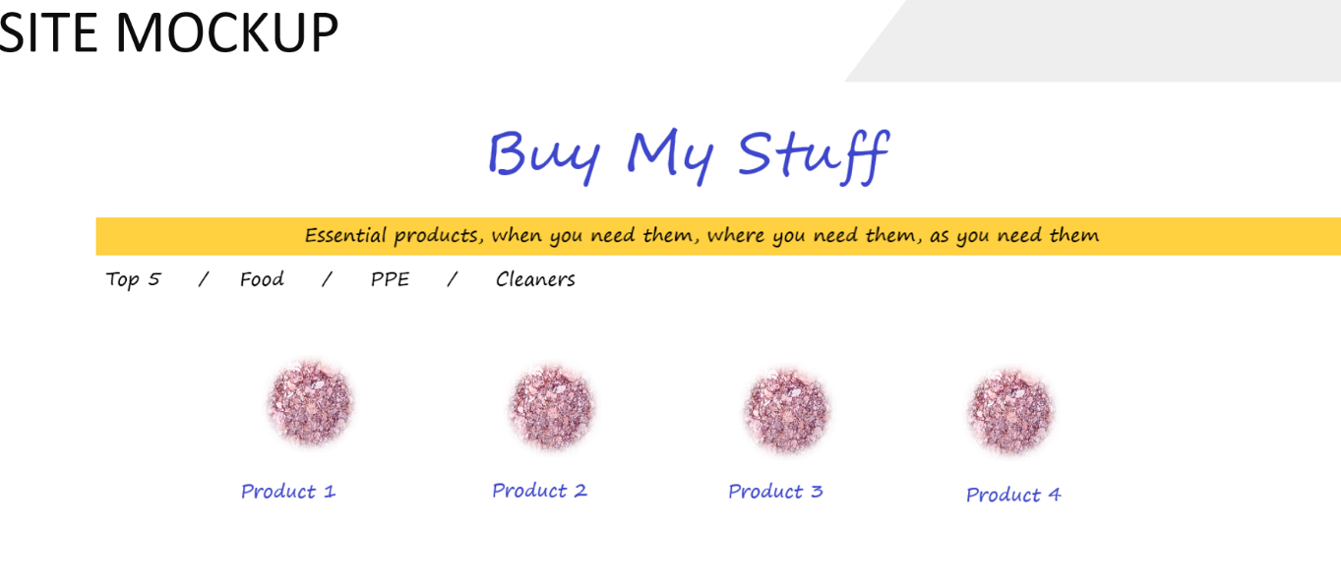

**UML Diagram: Shipping vs Delivery**

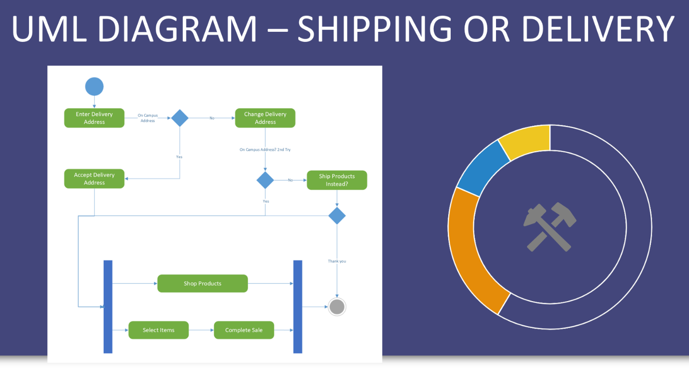

UML Diagram: Registration

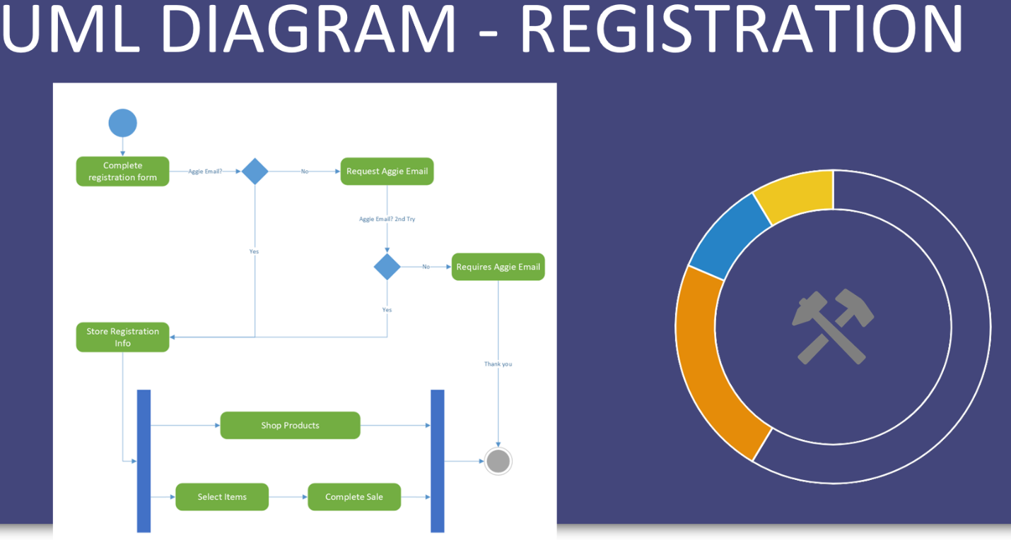

**Week 9: Project Journal**

**Fall 2021**

**Submitted By:**

**Soualiho Diomande, John Rierson, Ketrell Rogers, Rita Taylor**

**Week Ending: October , 2021**

* **Accomplishment 1: Finalized Requirements**

The team discussed and reviewed all the requirements needed to complete the project. Figured out what requirements needed further research.

* **Accomplishment 2: Draft PowerPoint**

The team started a draft of the PowerPoint for the presentation and made recommendations.

* **Accomplishment 3: Next Steps - Roles & Responsibilities**

Assigned roles and responsibilities for completing midterm PowerPoint and set a couple times to run through the presentation.

* **Individual Group Member Contribution: Soualiho Diomande**

Soualiho reviewed Manageability and Maintainability in the Requirements Specifications. He went into depth about the Maintenance, Monitoring and Operations. He also discussed the Performance section as well.

* **Individual Group Member Contribution: John Rierson**

John reviewed the Product Context, User Characteristics, Assumptions, Dependencies, and Constraints. He discussed the Data Management and Standards Compliance

* **Individual Group Member Contribution: Ketrell Rogers**

Ketrell reviewed the System Interface and Integration portion. He discussed the Network/Hardware Interfaces and System Interfaces. He discussed the Security regarding the Protection, Authentication and Authorization portion.

* **Individual Group Member Contribution: Rita Taylor**

Rita reviewed the Project Overview and Purpose/ Scope of the Specification.She discussed the Functional Requirements along with User Interface Requirements and Usability. She also reviewed the cases and discussed any shipping issues from previous meetings.

* **Issues and Solutions**

NA.

* **Acquired References and Dialogue**

NA

* **Goals for Next Week**
  + **Goal 1: Finalize Draft of Midterm Report**
  + **Goal 2: Presentation of the Midterm Report.**

**Attach weekly work here**

DRAFT Functional Requirements:

|  |  |
| --- | --- |
| **Section/ Requirement ID** | **Requirement Definition** |
| FR 1.0 | The website shall accept customer orders |
| FR 1.1 | The website shall display an image and description of each product |
| FR 1.2 | The website shall restrict adding sold out items to the shopping cart |
| FR 1.3 | The website shall display warning for products almost out of stock |
| FR 2.0 | The website shall allow users/customers to create a profile |
| FR 2.1 | The website shall require Aggie email addresses to create a profile |
| FR 2.2 | The website shall validate user profiles via email |
| FR 3.0 | The website shall display previous orders for customers with a profile created |
| FR 3.6 | The website shall allow users to login |
| FR 3.1 | The website shall be able to complete a sale |
| FR 3.2 | The website shall restrict range for delivery to 2 mile radius of A&T Main Campus |
| FR 3.3 | The website will allow shipping for users outside of the delivery range |
| FR 3.4 | The website shall NOT store credit card or banking information |
| FR 3.5 | The website shall produce a receipt detailing a customers’ purchase information |
| FR 3.7 | The website shall retain items in the shopping card when users log in |
| FR 3.8 | This website shall provide a shipping/order status |
| FR 4.0 | The website shall store customer and product data in a SQL database |

**DRAFT: Availability/Security Description :**

The website should be available for users and secured since they will use their credit card informations, it is defined as follow:

**Availability**

* The specific and measurable requirements for our E-commerce website is:
* The hours of operation are 24h/7 days
* The website will be available at any time and from anywhere but only students of NCAT will be able to make a purchase.
* There should be no Impact of downtime on users and business operations
* The Impact of scheduled and unscheduled maintenance on uptime and maintenance communications procedures will be less than 15%
* The website will be reliable at 100%

**Security**

* Specify the factors that will protect the system from malicious or accidental access, modification, disclosure, destruction, or misuse. For example:
* Creating scheduled backups
* SSL
* encryption of domain and private information
* DDOS protection
* Secure admin username and passwords
* protection from SQL injection
* protection from xss attacks
* strong password policy
* using secured web hosting

**Week 10: Project Journal**

**Fall 2021**

**Submitted By:**

**Soualiho Diomande, John Rierson, Ketrell Rogers, Rita Taylor**

**Week Ending: October 29th, 2021**

* **Accomplishment 1: Assigned pages to code and program**

The team met and assigned responsibilities for what to code and what pages.

* **Accomplishment 2: Discussed how and where we keep products**

The team found out there was only “convenient” store on campus to keep products..

* **Accomplishment 3: Brainstormed competition on campus and discuss next research**

The team brainstormed competition on campus and locally. Discussed next piece of research for project

* **Individual Group Member Contribution: Soualiho Diomande**

Soualiho attended sessions to brainstorm and start the coding of the main page and landing page.

* **Individual Group Member Contribution: John Rierson**

John attended sessions to brainstorm product skews, images, competition and product fulfillment.

* **Individual Group Member Contribution: Ketrell Rogers**

Ketrell attended sessions to brainstorm and start the coding for security, encryption, certificates and

research more information regarding security.

* **Individual Group Member Contribution: Rita Taylor**

Rita attended sessions to brainstorm formation of CSS, programming main code, and storage for current

coding and images.

* **Issues and Solutions**

NA.

* **Acquired References and Dialogue**

NA

**Week 11: Project Journal**

**Fall 2021**

**Submitted By:**

**Soualiho Diomande, John Rierson, Ketrell Rogers, Rita Taylor**

**Week Ending: November 5th, 2021**

* **Accomplishment 1: Develop CSS Scripts**

The team developed and reviewed CSS scripts, which define formatting standards for the site.

* **Accomplishment 2: Brainstorm Database Table Format**

The team met and brainstormed database tables and fields needed to store site and customer information.

* **Individual Group Member Contribution: Soualiho Diomande**

Soualiho participated in brainstorming and review sessions.

* **Individual Group Member Contribution: John Rierson**

John participated in brainstorming and review sessions

* **Individual Group Member Contribution: Ketrell Rogers**

Ketrell participated in brainstorming and review sessions

* **Individual Group Member Contribution: Rita Taylor**

Rita developed the CSS scripts for review and participated in brainstorming and review sessions

* **Issues and Solutions**

NA.

* **Acquired References and Dialogue**

The team decided to create page templates individually, then meet next week to decide which template to use. Once a template is finalized, we’ll use it to build each page.

* **Goals for Next Week**
  + **Goal 1: Build SQL scripts for database**
  + **Goal 2: Design page templates**
  + **Goal 3: Create shared drive to store files and code**

**Attach weekly work here**

**CSS Script**

img {

display: block;

margin-left: auto;

margin-right: auto;

}

a:link {

color: navy;

font-family: 'Comic Sans MS', sans-serif;

font-size: 20px;

text-decoration: none;

}

a:hover {

text-decoration: none;

color: #ff9900;

font-weight: bold;

}

p.proddesc {

font-family: 'Arial';

color: black;

font-size: 14px;

text-align: left;

}

p.prodname {

font-family: 'Arial';

color: black;

font-size: 30px;

}

table.prodlist {

width: 75%;

}

td.prodlist {

text-align: center;

height: 50px;

vertical-align: center;

color: navy;

font-family: 'Comic Sans MS', sans-serif;

font-size: 20px;

}

**Database Tables:**

* **Customers:**
  + Name
  + Street Address
  + City
  + State
  + Zip
  + Phone
  + Email address
  + BannerID
  + Username
  + Customer Number
* **Products:**
  + Product Name
  + Total Quantity
  + Total Sold
  + Sku
  + Price
  + Product Type
  + Description
* **Orders:**
  + Order Number
  + Customer Number
  + Product Sku
  + Quantity
  + Status
  + Delivery Type

**Week 12: Project Journal**

**Fall 2021**

**Submitted By:**

**Soualiho Diomande, John Rierson, Ketrell Rogers, Rita Taylor**

**Week Ending: November 12th, 2021**

* **Accomplishment 1: Build SQL scripts for database**

The team began developing scripts to create the database and tables.

* **Accomplishment 2: Created and shared OneDrive for file repository**

The team created a shared folder in OneDrive where we will store site files for collaborative work.

* **Individual Group Member Contribution: Soualiho Diomande**

Soualiho participated in brainstorming and review sessions.

* **Individual Group Member Contribution: John Rierson**

John created coding for inventory pages and narrowing down products.

* **Individual Group Member Contribution: Ketrell Rogers**

Ketrell participated in brainstorming and review sessions

* **Individual Group Member Contribution: Rita Taylor**

Rita developed the database scripts for review and participated in the review sessions

* **Issues and Solutions**

NA.

* **Acquired References and Dialogue**

The team decided to create page templates individually, then meet next week to decide which template to use. Once a template is finalized, we’ll use it to build each page.

* **Goals for Next Week**
  + **Goal 1: Continue building SQL scripts for database and add sample data**
  + **Goal 2: Design page templates**
  + **Goal 3:**

**Attach weekly work here**

**CSS Script**

img {

display: block;

margin-left: auto;

margin-right: auto;

}

a:link {

color: navy;

font-family: 'Comic Sans MS', sans-serif;

font-size: 20px;

text-decoration: none;

}

a:hover {

text-decoration: none;

color: #ff9900;

font-weight: bold;

}

p.proddesc {

font-family: 'Arial';

color: black;

font-size: 14px;

text-align: left;

}

p.prodname {

font-family: 'Arial';

color: black;

font-size: 30px;

}

table.prodlist {

width: 75%;

}

td.prodlist {

text-align: center;

height: 50px;

vertical-align: center;

color: navy;

font-family: 'Comic Sans MS', sans-serif;

font-size: 20px;

}

**Database Tables:**

* **Customers:**
  + Name
  + Street Address
  + City
  + State
  + Zip
  + Phone
  + Email address
  + BannerID
  + Username
  + Customer Number
* **Products:**
  + Product Name
  + Total Quantity
  + Total Sold
  + Sku
  + Price
  + Product Type
  + Description
* **Orders:**
  + Order Number
  + Customer Number
  + Product Sku
  + Quantity
  + Status
  + Delivery Type

**Week 13: Project Journal**

**Fall 2021**

**Submitted By:**

**Soualiho Diomande, John Rierson, Ketrell Rogers, Rita Taylor**

**Week Ending: November 19th, 2021**

* **Accomplishment 1: Refine SQL scripts for database**

The team began developing scripts to create the database and tables.

* **Individual Group Member Contribution: Soualiho Diomande**

Soualiho completed the coding for the home page and “contact us”. Soualiho also created a few web Templates so we can choose one for the final project.

* **Individual Group Member Contribution: John Rierson**

John is continuing to create coding for inventory pages and narrowing down products. John is also doing more research into what current students do for needs.

* **Individual Group Member Contribution: Ketrell Rogers**

Ketrell participated in brainstorming and review sessions, Also worked on creating security certificates and features for the website, and creating the web pages.

* **Individual Group Member Contribution: Rita Taylor**

Rita continued to refine the database scripts adding additional tables and sample data to be used during development

* **Issues and Solutions**

NA.

* **Acquired References and Dialogue**

The team decided to create page templates individually, then meet next week to decide which template to use. Once a template is finalized, we’ll use it to build each page.

* **Goals for Next Week**
  + **Goal 1: Continue building SQL scripts for database and add sample data**
  + **Goal 2: Design page templates**
  + **Goal 3: Refine Products**

**Attach weekly work here**

**Database Tables:**

* **Customers:**
  + Name
  + Street Address
  + City
  + State
  + Zip
  + Phone
  + Email address
  + BannerID
  + Username
  + Customer Number
* **Products:**
  + Product Name
  + Total Quantity
  + Total Sold
  + Sku
  + Price
  + Product Type
  + Description
* **Orders:**
  + Order Number
  + Customer Number
  + Product Sku
  + Quantity
  + Status
  + Delivery Type